

Operating Systems Lab 3

ITSC 200: Network Protocols and Security

Table of Contents

Lab Outcome(s) 2

Reading 2

Introduction 2

1.0 Practice using basic Linux shell commands 3

References 4

Lab Outcome(s)

* Gain familiarity with the Linux (Bash) command line.

Reading

* Linux_cheatsheet_1

Introduction

This lab is to familiarize you with using shell commands in a Linux environment. We will use the VM you created on the cloud or at home on your laptop in Virtualbox.

1.0 Use basic Linux commands

1. Login into your VM with the account you created during the install. Open a Terminal window.
2. You will see a window, as below.
3. Submit this page and the following pages as your OS_lab3 assignment.
4. Beside each numbered question or action below, write either the command(s) used or the answer if the step is asking a question.  
     
   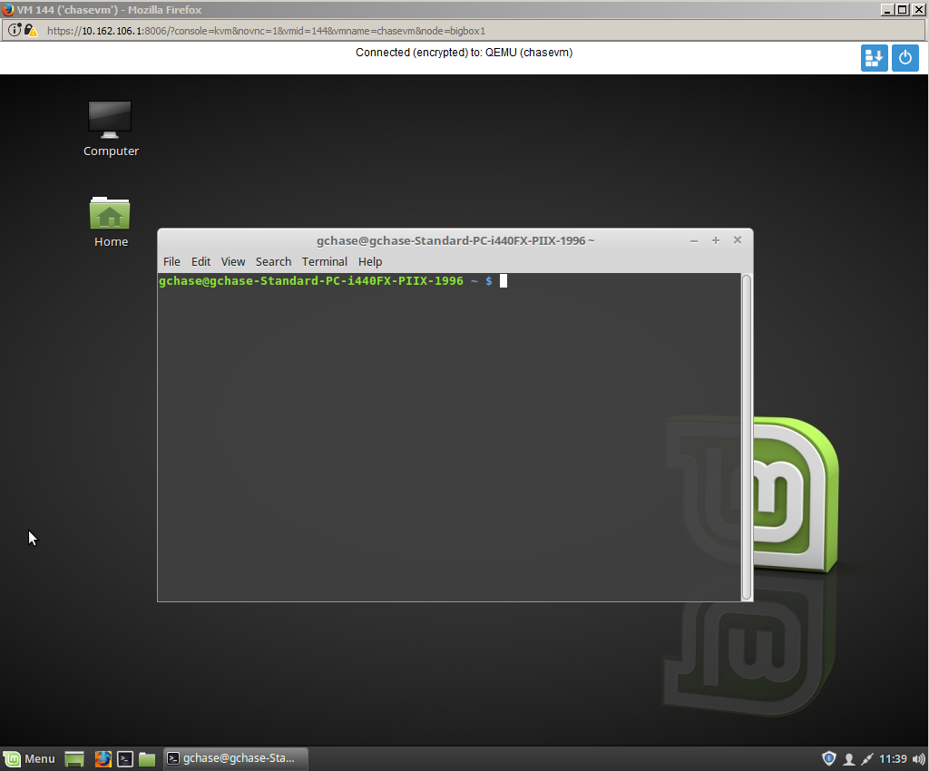
5. Find the IP address of the VM.  
     
   IP Address ___________________________________
6. Create a file structure under your home directory that looks like the graphic below.
7. Make /home/<username>/myfiles your current directory. Check to make sure you are in the myfiles directory.
8. Create an empty new file in each directory that follows the directory numbering pattern (ie file2 in dir2, file3 in dir3, …)
9. Create two new users in your Linux VM. Use reasonable passwords so your classmates won’t mess with your VM (not that I’m accusing anyone). Use whatever usernames you want but I will just call them user1 and user2.
10. Modify ownership and permissions on your directories such that :  
    1. Other users have no access to any of the directories in your myfiles tree. NOTE that this will even apply to the root user when you are done.
    2. nobody but your current user has any access to dir1
    3. user1 has ownership and full access to dir2 and dir4
    4. user2 has full access and ownership to dir3
    5. user2 has read and execute permission to dir4 but cannot see anything in dir2 (hint: you will need to use groups to do this)
11. Log in as user1 and create a sym link in dir2 that points to file4.
12. Edit sym link file and add the line “This is my file”. Save it.
13. Check to see if the contents of file4 have changed.
14. Log in as user2 and try to see the contents of dir2. Can you ?
15. Can you go into dir4 ?
16. Can you see any files in dir4 ?
17. Try to go into dir1. What was the result ?
18. Check to see what the disk usage is for each of your top-level directories (ie: /etc, /usr, /home, …)
19. What partitions do you have in your VM and what is the size of each in Gb’s ?
20. Find the users that you created in /etc/passwd and /etc/shadow.
21. Remove the entire myfiles directory structure with one command (you may have to modify the file and directory permissions first). **Be very careful with this !**
22. Shutdown your VM and release the floating IP address if one is used.

References

Linux_cheatsheet_1

Blank page if necessary to make pages an even number

**DO NOT DELETE THE SECTION BREAK BELOW. DELETING IT MAY IMPACT THE FORMATTING IN THIS DOCUMENT.**